Chatbot Persona:

Definition: Assistant Siri is a friendly and helpful virtual assistant chatbot designed to make users feel comfortable and supported. It uses natural language processing (NLP) to understand and respond to simple English statements and queries which makes it more user friendly.

Attributes:

Tone: Friendly, approachable, and patient.

Style: Conversational and informal.

Visual Representation: A simple and unobtrusive text-based interface, perhaps with a smiling emoji to convey friendliness.

Conversation Flow:

[Greeting Customer by default]

Assistant Siri: Welcome, how can I assist you?

User: Hi

Assistant Siri: Hello, how can I help you?

User: I want to buy airpods

Assistant Siri: Which brands do you prefer?

* Apple
* Boat
* CrossBeats
* Any other?

User: Apple

Assistant Siri: Great choice!

User: How much does the apple airpods costs

Assistant Siri: Certainly! Apple airpods ranges from 20k to 40k.Please provide configuration details will get back to you.

User: That’s all I needed

Assistant Siri: You're welcome! If you have any more questions  
or need assistance in the future, feel free to ask. Have a great day! 😊

Response Configuration:

INTENTS:

An intent represents the purpose of a user's input. You define an intent for each type of user request you want your application to support. Intents helps the chatbot to understand the user’s request.

Using IBM cloud account Watson assistant was created and launched named Siri and have created intents under the Dialog nodes.

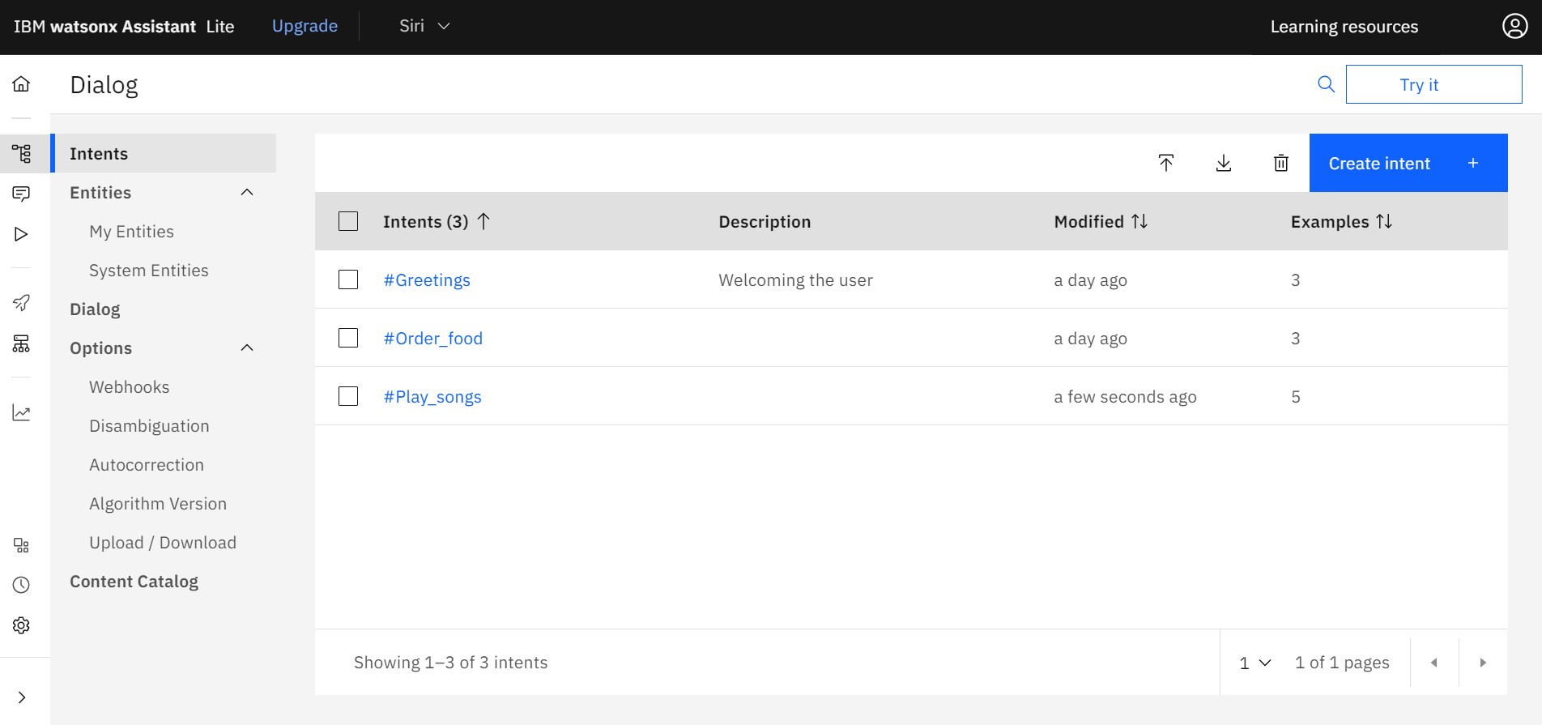

For each intents various examples are provided which helps the chatbot to recognise it easier. Here, Three intents and created for ‘Greetings’, ‘Order_food’, ‘Play_songs’ and examples according to the intents created.

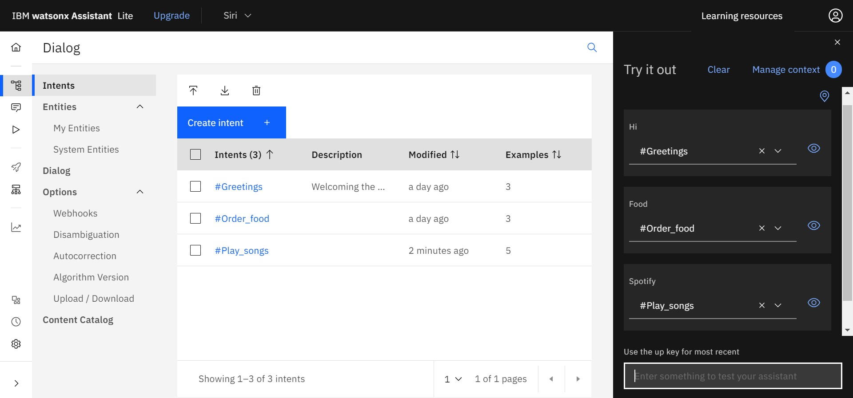

The created intents are tested using the try it option. Each intent typically corresponds to a dialog node that contains responses and actions related to that intent.

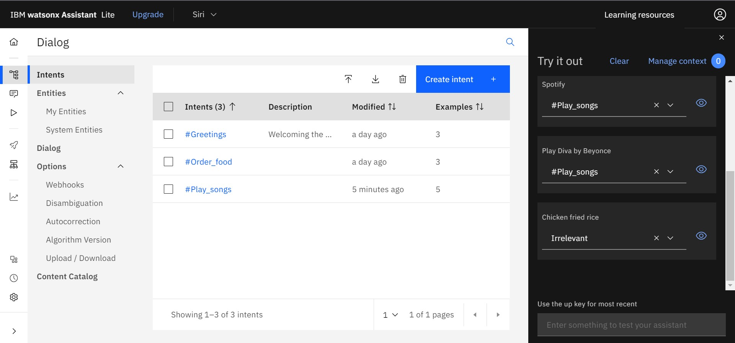

If the input is related to any of the intents created, then we can teach the Assistant by choosing the any of the intent name that its related to.

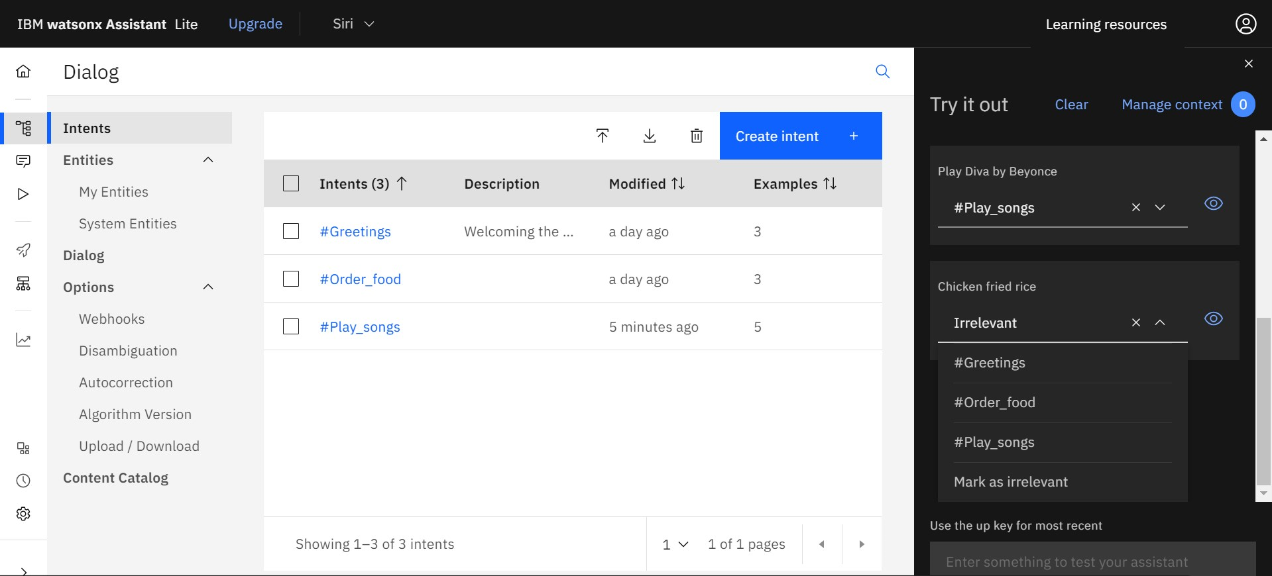

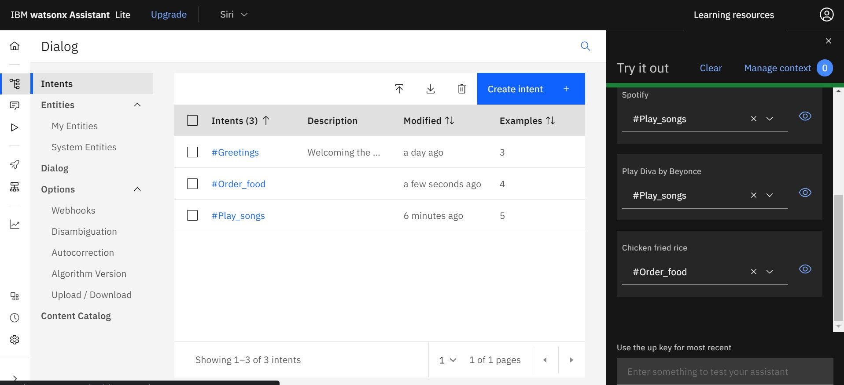

ENTITIES:

An entity represents a term or object that is relevant to your intents and that provides a specific context for an intent.

The entities are created using the create entity option under my entities.

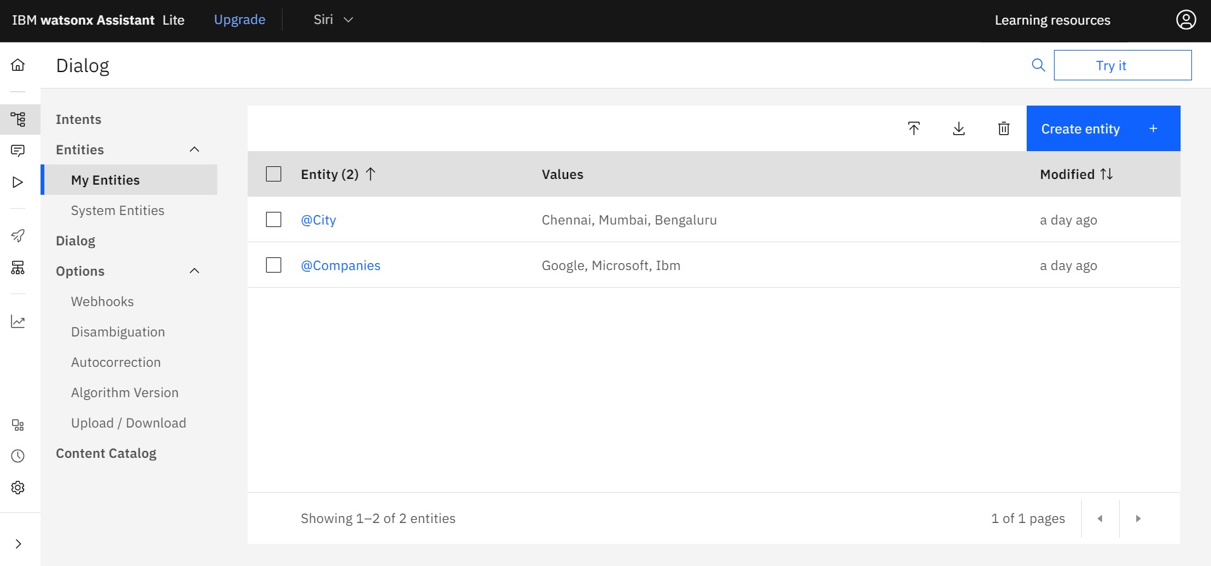

Two entities are created namely @city and @Companies. @ symbol is used to represent that it’s an entity.

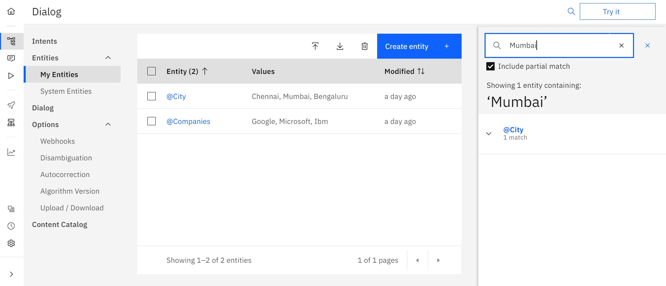

Using the search option we checked whether the input given by the user is recognised by the Assistant. Entities help extract specific information, while intents guide the overall conversation flow.